Activity – Applying Usability
In this module we’ve looked at a range of usability tools including Personas,
Card Sorting, Task Analysis, Use Cases, and Surveys. Remember the video
we watched in module two about a polling booth set up by the Australian
Electoral Commission? In small groups, select one of the tools and apply it to
developing a new online voting system for the AEC:

Personas – use the approach outlined in the module book to develop one
persona for a person who would use this technology (voter/AEC employee)
Australian Voter Persona:-
Who | Demographic Information | Goals
Sandra Blue | Age:37  Location:Brisbane, 4000  Job Title:Sales Rep | Life Goals:  Sandra wants to be a person whois part of a collective voice. | End Goals:  Sandra wants her vote to count and wants to do it quickly and efficiently. | Experience Goals:  Sandra wants to feel proud of their country and what they do for not only their citizens, but for the world.

Card sorting – complete a card sorting exercise using the cards provided by
your instructor
Cannot do this as I have no cards from the instructor to do it.

Task analysis – complete a task analysis for the voting process
This is done from the perspective of a voter…

Step No. | Task | What to do…
1 | Line up | Arrive at a polling site and line up to vote
2 | Register | Arrive at the registering dress and give your details to be marked off the list and given your ballots.
3 | Vote | Take your ballots to a polling booth and fill them out as you see fit.
4 | Deposit | Take your filled out ballots and deposit then in the appropriate container for that ballot.
5 | Leave | You are now done voting and can leave the premises.

Use cases – write a use case for the voting process
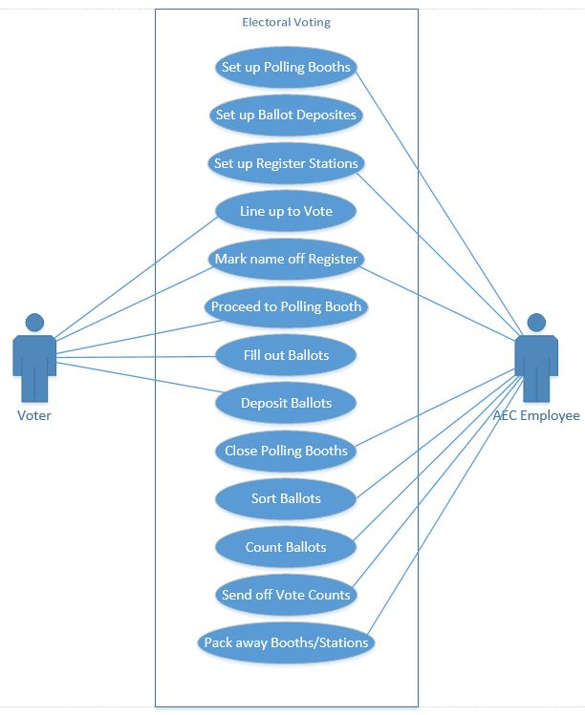
Surveys – generate a list of survey questions for the voting system: what do
you need to know?
Survey questions:-
- What is your age bracket?
- Do you like the current paper voting system? If yes, why? If no, why not?
- Would you like an electronic voting system? If yes, why? If no, why not?
- Would you prefer one or the other or a choice of either?
- What technological devices do you own/use? (Gives us an idea of their technological capability)

Advanced Activity – Comparing the tools
The tools we’ve covered are related both to each other and to your future
design, but what are the connections? Work together to compare the tools and
identify the common threads and the differences.

How would you then use these tools in your design stage?

Similarities:
- Informal Usability Testing, Usability Testing, Expert Reviews are all evaluations.
- Alls tools are centric on the tools
- User Interviews, Personas, User Research – all regarding users.

Differences:
Number of practitioners using each tool varies significantly. The ranges are as follows:

- Above 70%: Informal Usability Testing, Expert Reviews, User Interviews, User Research
- 50-70%: Formal Usability Testing, Personas, Requirements Gathering, Task Analysis, Card Sorting
- 33-50%: Contextual Inquiry, Focus Groups, Competitive Benchmarking, Remote Usability Testing, Surveys,
- Less than 33%: Eye Tracking, Accessibility Reviews and testing, Analyse web metrics, Market Reviews

